**Hallux Schema Additions**

The purpose of the Hallux schema changes is to serve as a sample solution to the following business requirement.

Hallux would like to expand their business to support social media and streaming.

The proposed schema changes shown below are designed to support the new business requirements. The first addition concerns “fans” of a band. The Band_Follower table would store information about a band’s followers. The addition of the platform and stream tables will allow for the storing of information about the streaming of media. Lastly, the addition of the playlist set of tables facilitates the creation of playlists that can be shared and rated among Hallux users.

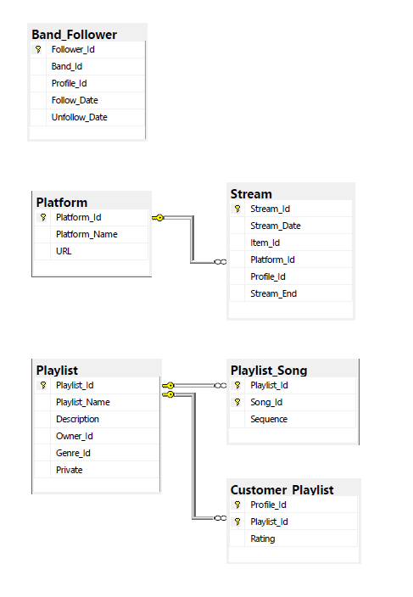

Appendix 1 – Data Dictionary

|  |  |  |  |
| --- | --- | --- | --- |
| **Table** | **Column** | **Data Type** | **Description** |
| Platform | Platform_Id | Integer | Unique Id |
| Platform | Platform_Name | Varchar(30) | Streaming platform name |
| Platform | URL | Varchar(1000) | Link to platform |
|  |  |  |  |
| Stream | Stream_Id | Integer | Unique Id |
| Stream | Item_Id | Integer | Item streamed |
| Stream | Platform_Id | Integer | Platform from which content was streamed |
| Stream | Stream_Date | Datetime | Date content was streamed |
| Stream | Profile_Id | Integer | Profile_Id that streamed the content |
| Stream | Stream_End | Datetime | Date / Time streaming ended |
|  |  |  |  |
| Playlist | Playlist_Id | Integer | Unique Id |
| Playlist | Playlist_Name | Varchar(30) | Display name of the playlist |
| Playlist | Description | Varchar(100) | Description of the playlist |
| Playlist | Owner_Id | Integer | Profile_Id that created / owns the playlist |
| Playlist | Genre_Id | Integer | Genre of the playlist |
| Playlist | Private | Binary | Can the playlist be shared with other profiles? |
|  |  |  |  |
| Playlist_Song | Playlist_Id | Integer | Unique Id |
| Playlist_Song | Song_Id | Integer | Song |
| Playlist_Song | Sequence | tinyint | Order in which to play the songs |
|  |  |  |  |
| Customer_Playlist | Profile_Id | Integer | Unique Id |
| Customer_Playlist | Playlist_Id | Integer | Playlist |
| Customer_Playlist | Rating | tinyint | 1-10 rating of the playlist |
|  |  |  |  |
| Band_Follower | Follower_Id | Integer | Unique Id |
| Band_Follower | Band_Id | Integer | Band |
| Band_Follower | Profile_Id | Integer | Profile |
| Band_Follower | Follow_Date | Datetime | Date started following |
| Band_Follower | Unfollow_Date | Datetime | Date stopped following |
|  |  |  |  |

Appendix 2 – Data Definition Language

CREATE TABLE Platform

(

Platform_Id int NOT NULL,

Platform_Name varchar(30) NOT NULL,

URL varchar(1000) NOT NULL,

CONSTRAINT pk_Platform PRIMARY KEY CLUSTERED (Platform_Id)

)

go

CREATE UNIQUE INDEX idx_Platform_Name ON Platform (Platform_Name)

go

CREATE TABLE Stream

(

Stream_Id int NOT NULL,

Item_Id int NOT NULL,

Platform_Id int NOT NULL,

Profile_Id int NULL,

Stream_Date Datetime NOT NULL,

Stream_End Datetime NULL,

CONSTRAINT pk_Stream PRIMARY KEY CLUSTERED (Item_Id, Platform_Id, Stream_Date)

)

Go

ALTER TABLE Stream ADD CONSTRAINT fk_Stream_Item FOREIGN KEY (Item_Id) REFERENCES Item (Item_Id)

go

ALTER TABLE Stream ADD CONSTRAINT fk_Stream_Platform FOREIGN KEY (Platform_Id) REFERENCES Platform (Platform_Id)

Go

ALTER TABLE Stream ADD CONSTRAINT fk_Stream_Profile FOREIGN KEY (Profile_Id) REFERENCES Customer_Profile (Profile_Id)

Go

CREATE TABLE Playlist

(

Playlist_Id int NOT NULL,

Playlist_Name varchar(30) NOT NULL,

Description varchar(100) NULL,

Owner_Id int NULL,

Genre_Id int NULL,

Private binary NULL,

CONSTRAINT pk_Playlist PRIMARY KEY CLUSTERED (Playlist_Id)

)

Go

CREATE UNIQUE INDEX idx_Playlist_Name ON Playlist (Playlist_Name)

go

ALTER TABLE Playlist ADD CONSTRAINT fk_Playlist_Genre FOREIGN KEY (Genre_Id) REFERENCES Genre (Genre_Id)

go

ALTER TABLE Playlist ADD CONSTRAINT fk_Playlist_Owner FOREIGN KEY (Owner_Id) REFERENCES Customer_Profile (Profile_Id)

go

CREATE TABLE Playlist_Song

(

Playlist_Id int NOT NULL,

Song_Id int NOT NULL,

Sequence tinyint NULL,

CONSTRAINT pk_Playlist_Song PRIMARY KEY CLUSTERED (Playlist_Id, Song_Id)

)

go

ALTER TABLE Playlist_Song ADD CONSTRAINT fk_Playlist_Song_Song FOREIGN KEY (Song_Id) REFERENCES Song (Song_Id)

go

ALTER TABLE Playlist_Song ADD CONSTRAINT fk_Playlist_Song_Playlist FOREIGN KEY (Playlist_Id) REFERENCES Playlist (Playlist_Id)

go

CREATE TABLE Customer_Playlist

(

Profile_Id int NOT NULL,

Playlist_Id int NOT NULL,

Rating tinyint NULL,

CONSTRAINT pk_Customer_Playlist PRIMARY KEY CLUSTERED (Profile_Id, Playlist_Id)

)

go

ALTER TABLE Customer_Playlist ADD CONSTRAINT fk_Customer_Playlist_Profile FOREIGN KEY (Profile_Id) REFERENCES Customer_Profile (Profile_Id)

go

ALTER TABLE Customer_Playlist ADD CONSTRAINT fk_Customer_Playlist_Playlist FOREIGN KEY (Playlist_Id) REFERENCES Playlist (Playlist_Id)

Go

CREATE TABLE Band_Follower

(

Follower_Id int NOT NULL,

Band_Id int NOT NULL,

Profile_Id int NOT NULL,

Follow_Date Date NOT NULL,

Unfollow_Date Date NULL,

CONSTRAINT pk_Band_Follower PRIMARY KEY (Follower_Id)

)

go

CREATE UNIQUE CLUSTERED INDEX idx_Band_Follower ON Band_Follower (Band_Id, Profile_Id, Start_Date)

go

ALTER TABLE Band_Follower ADD CONSTRAINT fk_Band_Follower_Band FOREIGN KEY (Band_Id) REFERENCES Band (Band_Id)

go

ALTER TABLE Band_Follower ADD CONSTRAINT fk_Band_Follower_Profile FOREIGN KEY (Profile_Id) REFERENCES Customer_Profile (Profile_Id